Local Labor Market Conditions and Career and Technical Education Teacher Turnover
Purpose
The purpose of this study is to examine the relationship between local labor market conditions and Career and Technical Education (CTE) teacher turnover, and to assess whether this relationship varies across CTE career cluster areas. As CTE has expanded as a strategy for preparing a STEM-capable workforce and narrowing economic opportunity gaps (Asunda, 2012; Jacob & Ricks, 2023), districts increasingly rely on CTE teachers to deliver instruction that integrates academic content with applied, industry-relevant skills. Nearly all school districts now offer some form of CTE programming (Gray & Lewis, 2018), and evidence links CTE participation to improved student attendance, graduation rates, and postsecondary outcomes (Bonilla, 2020; Brunner et al., 2021; Dougherty, 2016; Dougherty, 2018; Hemelt et al., 2019; Plasman et al., 2017). Additionally, CTE has increasingly been used as a mechanism for integrating STEM content and skills into applied coursework. While CTE offerings span a wide range of occupational areas, STEM-oriented pathways have expanded within the CTE space, positioning CTE as an important vehicle for broadening access to applied STEM learning (Asunda, 2014; Dougherty, 2020).
Despite the growing importance of CTE, recruiting and retaining qualified CTE teachers remains a persistent challenge (Devier, 2019). State CTE leaders consistently identify expanding access to industry experts in secondary education as a top priority (Advance CTE, 2016), and more than half of states report shortages in at least one CTE area (U.S. Department of Education, 2025). These shortages may be particularly acute in high-growth, high-wage, and STEM-related fields, where teachers’ industry-aligned skills are highly valued outside of education. This may create a problem where schools struggle most to staff CTE programs in the very fields that offer the greatest economic returns for students.
Building on prior research linking teacher mobility to local labor market conditions, this study investigates whether stronger local labor markets are associated with higher rates of CTE teacher turnover. It further examines heterogeneity across CTE career clusters to understand whether teachers in certain clusters are more responsive to local economic conditions than teachers in other fields. By clarifying how local labor markets shape CTE teacher retention, this study aims to inform policy discussions related to CTE staffing, workforce alignment, and the long-term stability of the CTE teaching workforce in high-demand sectors.
Background and Context
A substantial body of research documents the growing role of Career and Technical Education in improving educational and economic outcomes for students. Studies consistently show that CTE participation is associated with improved attendance, higher rates of high school completion, and increased postsecondary enrollment (Bonilla, 2020; Brunner et al., 2021; Dougherty, 2016; Dougherty, 2018; Hemelt et al., 2019; Plasman et al., 2017). More recently, scholars have emphasized the increasing alignment of CTE with STEM fields, noting that CTE serves as a mechanism for integrating STEM content into applied coursework and expanding access for students who may not participate in advanced academic STEM pathways (Asunda, 2014; Dougherty, 2020).
Central to the effectiveness of these programs are CTE teachers, who combine pedagogical responsibilities with occupational expertise. However, concerns persist regarding the recruitment and retention of CTE teachers (Devier, 2019). These challenges are distinct from shortages in traditional academic subjects, as CTE teachers’ skills are often directly transferable to non-education employment, raising the opportunity cost of remaining in the classroom.
A well-established literature on teacher labor supply and turnover emphasizes the role of alternative employment opportunities and local economic conditions. Drawing on theories of occupational choice and turnover (Mobley et al., 1979; Carsten & Spector, 1987), prior research shows that teachers are less likely to exit during periods of high unemployment and more likely to leave as labor markets tighten (Bacher-Hicks, 2022; Bleiberg & Kraft, 2023; Goldhaber & Theobald, 2022; Harbatkin et al., 2025). There is reason to believe that the relationship between teacher turnover and local labor market strength may be particularly true for CTE teachers, as they are skilled both in education and teaching; however, relatively little research focuses specifically on CTE teachers. Existing studies of CTE teacher turnover emphasize in-school factors such as administrative support, work engagement, and job satisfaction (Clark et al., 2014; Morris, 2006; Park & Johnson, 2019). While these factors are important, they may not fully capture the labor market dynamics faced by CTE teachers with industry-aligned skills. Recent evidence suggests that CTE teachers with occupational licenses and those in STEM-related fields exit teaching at higher rates and earn substantially more after leaving (Kistler et al., 2024). Similarly, Harbatkin et al. (2025) find that STEM teachers exhibit higher conversion from intent to leave to actual exit, consistent with stronger outside options.
Figure 1 draws on the Roy model of occupational choice (Roy, 1951) to situate CTE teacher turnover within local labor markets. The three lines represent hypothetical pay from industry in a strong and weak economy, respectively, and in teaching, at different levels of skill. Importantly, the slope for teaching (orange line) is flat or nearly so because greater skills in industry do not translate into higher pay in the classroom. In industry, on the other hand, workers stand to earn higher wages when they are more skilled. The slope is steeper in a strong economy (magenta line) or a high-demand field (blue dashed line) than a weak economy (green line) or low-demand field (orange dashed line) because the returns to skills will be higher in a more competitive labor market. Thus, if the teacher’s skills align with a high-demand sector of the local economy, the availability of attractive outside opportunities makes exit from teaching more likely (Chingos and West, 2012; Nagler, 2020; Podgursky et al., 2004).
Method
This study addresses two research questions:
- To what extent are local labor market conditions associated with CTE teacher turnover?
- To what extent does the relationship between local labor market conditions and CTE teacher turnover vary across CTE career cluster areas?
Together, these questions are designed to assess whether economic conditions external to schools shape CTE teacher retention decisions and whether these effects are stronger in high-demand, STEM-aligned career pathways where outside employment options are likely more attractive.
Study Design and Data
This study employs a quantitative, longitudinal research design using statewide administrative data from Florida Department of Education spanning the 2018–2019 through 2022–2023 school years. The analytic dataset includes all teachers who taught at least one CTE course during this period and focuses on teachers identified as “primary CTE” based on job codes (N = 7,461 unique teachers). The teacher-level administrative records include detailed information on certification type, salary, years of teaching experience, demographic characteristics, course assignments, and district separation dates and reasons.
To capture local labor market conditions, the teacher-by-year data are merged with publicly available county-level economic indicators from three sources: (1) gross domestic product (GDP) data from the U.S. Department of Commerce’s Bureau of Economic Analysis, (2) unemployment rates from the Bureau of Labor Statistics, and (3) Quarterly Workforce Indicators (QWI) from the U.S. Census Bureau, which provide industry-specific measures of job creation, hiring, and earnings. QWI and GDP data allow the analysis to capture variation in economic conditions across industries that align with CTE career clusters. Teachers are matched to labor market indicators using their employing county. Because Florida school districts are county-based, district and county boundaries align, minimizing geographic mismatch between labor market measures and teachers’ workplaces.
Measures
The primary outcomes are two measures of CTE teacher turnover: (1) exiting the school district and (2) exiting the teaching profession altogether. A teacher is coded as exiting the district if a separation date appears in the administrative record at the end of a given school year. Exiting the teaching profession is defined using separation reason codes indicating departure from education (e.g., resigning for work outside education, retirement, contract expiration, or job abandonment). Figure 2 shows both series peaking in 2021–22 (district exit 8.7% and leaving teaching 7.1%) and declining in 2022–23 to 7.5% and 6.3%, respectively.
The key independent variables are measures of local labor market conditions, including county-level unemployment rates, overall county GDP growth, and industry-specific labor market indicators drawn from QWI and GDP data. Table 1 presents descriptive statistics for the local labor market indicators used in the analysis, reported separately for teachers who remain in their district, those who exit the district, and those who leave teaching altogether.
Empirical Strategy
To address Research Question 1, the study estimates the following linear probability model:
$${\text{Turnover}}_{isct}=β_{0}+β_{1}{\text{LaborMarketCondition}}_{ct}+αX_{it}^{'}+λY_{st}^{'}+ζZ_{ct}^{'}+π_{t}+κ_{c}+ε_{isct}$$
where ${\text{Turnover}}_{isct}$is an indicator equal to one if teacher $i$, in school $s$, located in county $c$, exits the district or the teaching profession by the end of school year $t$. The key explanatory variable, ${\text{LaborMarketCondition}}_{ct}$, represents a measure of local labor market conditions in county $c$and year $t$, such as the unemployment rate, GDP growth, or industry-specific hiring activity.
The vector $X_{it}^{'}$includes teacher-level characteristics such as race and ethnicity, years of teaching experience, age, certification type, salary, and educational background. The vector $Y_{st}^{'}$includes school-level characteristics such as student demographic composition (race, economic disadvantage, English learner status), logged enrollment, and non-CTE teacher turnover rates. The vector $Z_{ct}^{'}$includes time-varying county characteristics such as population size and demographic composition. The model includes year fixed effects ($π_{t}$) to account for statewide shocks and trends, and county fixed effects ($κ_{c}$) so that identification relies on within-county changes in labor market conditions over time. Standard errors are clustered at the county level.
The coefficient of interest, $β_{1}$, represents the estimated change in the probability of CTE teacher turnover associated with a one-unit change in the local labor market condition. For example, when the labor market measure is the unemployment rate, $β_{1}$captures the change in the probability of turnover associated with a one–percentage-point increase in county unemployment.
Heterogeneity by Career Cluster
To address Research Question 2, the analysis examines heterogeneity in the relationship between local labor market conditions and CTE teacher turnover across career cluster areas. Table 2 reports the share of CTE courses by cluster, and I focus on clusters with adequate sample size and variation. First, the sample is restricted to individual career clusters with sufficient sample size and variation, and Equation (1) is estimated separately within each cluster. This approach provides cluster-specific estimates that are straightforward to interpret and compare.
Second, to increase statistical power and formally test differences across clusters, the study estimates interaction models that extend Equation (1) by interacting the labor market condition variable with indicators for CTE career clusters. These models allow direct tests of whether the association between labor market conditions and turnover differs significantly across clusters, consistent with the hypothesis that teachers in high-demand, STEM-aligned pathways face stronger outside options and higher opportunity costs of remaining in the classroom.
Findings or Results
I focus first on estimates using the county unemployment rate as the primary measure of local labor market conditions (see Table 3). For district exit, the results show no statistically significant relationship between unemployment and the likelihood that CTE teachers leave their employing district. Across specifications, changes in county unemployment are not meaningfully associated with district-to-district mobility among CTE teachers. In contrast, I find a statistically significant association between county unemployment rates and CTE teachers’ exits from teaching that are explicitly coded as leaving to work outside of education. Specifically, a one–percentage-point increase in county unemployment, reflecting a weaker local labor market, is associated with a small but statistically significant decrease in the probability that CTE teachers exit teaching to work outside of education. The estimated coefficient is approximately –0.003, indicating that CTE teachers are modestly less likely to leave the profession as unemployment rises. Although the magnitude of this effect is small, it is consistent across model specifications and aligns with theoretical expectations and prior evidence that teacher exits are countercyclical. Taken together, these findings suggest that local labor market conditions, as measured by unemployment, are more strongly related to teachers’ decisions to exit teaching for employment outside of education.
I next examine estimates using county-level GDP percent change as a measure of local labor market strength (see Table 4). The results indicate that strong GDP growth is associated with higher rates of both CTE teacher district exit and exits from teaching to work outside of education, relative to counties with moderate or negative GDP change. However, district exit is the only outcome for which the estimate is statistically significant. Specifically, teachers in counties with strong labor markets, defined by above-average GDP growth, are approximately 1 percentage point more likely to exit their district than teachers in counties with moderate economic conditions.
I find no statistically significant relationships between CTE teacher turnover and either firm job gains or the replacement hiring rate (see Table 4), suggesting that these dimensions of local labor demand are less strongly associated with CTE teacher exits than broader measures of labor market strength.
I next examine whether the relationship between county level unemployment rates and CTE teacher turnover varies across career clusters by estimating interaction models between county unemployment rates and career cluster indicators (See Table 5). The interaction estimates reveal meaningful heterogeneity across clusters, with statistically significant relationships concentrated in a small number of fields. Notably, Architecture and Construction is the only career cluster for which unemployment is significantly associated with both district exit and exits from teaching to work outside of education. In this cluster, increases in the unemployment rate, indicative of weaker local labor markets, are associated with lower probabilities of CTE teacher turnover across both outcomes. Across other career clusters, statistically significant relationships are more prevalent for the outcome measuring exits from teaching to work outside of education than for district exit. In several clusters, increases in unemployment are significantly associated with a lower likelihood that CTE teachers leave the profession for non-education employment, while estimates for district exit remain small and statistically insignificant. This pattern suggests that local labor market conditions are more strongly related to decisions to leave teaching altogether than to mobility within the education sector. Taken together, these results indicate that responsiveness to local labor market conditions is not uniform across CTE fields and is concentrated in clusters where industry employment opportunities may be particularly salient.
Conclusions and Implications
As states and districts increasingly invest in CTE as a means of promoting economic mobility and meeting employer demand, the success of these efforts depends critically on the ability to recruit and retain qualified CTE teachers. This study contributes to a growing literature on teacher labor markets by shifting attention from traditional academic teachers to CTE teachers, an underexplored but policy-relevant segment of the teacher workforce.
The findings suggest that CTE teachers are responsive to local labor market conditions when deciding whether to exit teaching for employment outside of education, and that these responses vary across career clusters. This has important implications for CTE policy and for the long-term sustainability of CTE systems. As local labor markets strengthen, school leaders may need to anticipate greater challenges in recruiting and retaining CTE teachers, particularly in fields with strong industry demand. Districts may therefore need to adopt targeted strategies such as differentiated compensation, flexible staffing arrangements, or partnerships with local employers to incentivize CTE teachers to remain in the classroom and ensure a stable, qualified workforce. At the state level, investments in alternative certification pathways, industry-to-teaching pipelines, and policies that reduce barriers for industry professionals entering teaching may help mitigate staffing challenges and support the continued expansion of high-quality CTE programs.
This study has several limitations. First, the analysis assumes that teachers respond predictably to local labor market conditions, but it cannot capture individual decisions shaped by non-economic factors such as family circumstances, health, or personal preferences. In addition, administrative separation records provide limited information about teachers’ post-exit outcomes, making it difficult to distinguish between those who leave teaching to work outside of education and those who exit the labor force altogether. Second, the analysis measures labor market conditions at the county level and cannot account for the extent to which teachers may be influenced by economic conditions in neighboring counties. Third, the empirical models treat counties as comparable units, though teacher responses to local economic conditions may differ meaningfully between large metropolitan areas and smaller or more rural counties. Finally, analyses examining heterogeneity across career clusters are constrained by sample size in some industries, which may limit statistical power and the generalizability of cluster-specific findings.

Appendix A – References
Advance CTE. (2016). The state of career technical education: Increasing access to industry experts in high schools. https://careertech.org/resource/the-state-of-career-technical-education-increasing-access-to-industry-experts-in-high-schools/
Asunda, P. A. (2012). Standards for technological literacy and STEM education delivery through career and technical education programs. Journal of Technology Education, 23(2), 44–60.
Asunda, P. A. (2014). A conceptual framework for STEM integration into curriculum through career and technical education. Journal of STEM Teacher Education, 49(1), 4.
Bacher-Hicks, A., Chi, O. L., & Orellana, A. (2023). Two years later: How COVID-19 has shaped the teacher workforce. Educational Researcher, 52(4), 219–229.
Bleiberg, J. F., & Kraft, M. A. (2023). What happened to the K–12 education labor market during COVID? The acute need for better data systems. Education Finance and Policy, 18(1), 156–172.
Bonilla, S. (2020). The dropout effects of career pathways: Evidence from California. Economics of Education Review, 75, 101972.
Brunner, E. J., Dougherty, S. M., & Ross, S. L. (2021). The effects of career and technical education: Evidence from the Connecticut Technical High School System. The Review of Economics and Statistics, 1–46.
Carsten, J. M., & Spector, P. E. (1987). Unemployment, job satisfaction, and employee turnover: A meta-analytic test of the Muchinsky model. Journal of Applied Psychology, 72(3), 374.
Chingos, M. M., & West, M. R. (2012). Do more effective teachers earn more outside the classroom? Education Finance and Policy, 7(1), 8–43. https://doi.org/10.1162/EDFP_a_00052
Clark, M. S., Kelsey, K. D., & Brown, N. R. (2014). The thornless rose: A phenomenological look at decisions career teachers make to remain in the profession. Journal of Agricultural Education, 55(3), 43–56.
Devier, B. H. (2019). Teacher shortage and alternative licensure solutions for technical educators. The Journal of Technology Studies, 45(2), 48–59.
Dougherty, S. M. (2016). Career and technical education in high school: Does it improve student outcomes? Thomas B. Fordham Institute.
Dougherty, S. M. (2018). The effect of career and technical education on human capital accumulation: Causal evidence from Massachusetts. Education Finance and Policy, 1–52.
Dougherty, S. M., & Harbaugh Macdonald, I. (2020). Can growth in the availability of STEM technical education improve equality in participation? Evidence from Massachusetts. Journal of Vocational Education & Training, 72(1), 47–70.
Goldhaber, D., & Theobald, R. (2022). Teacher attrition and mobility over time. Educational Researcher, 51(3), 235–237. https://doi.org/10.3102/0013189X211060840
Gray, L., & Lewis, L. (2018). Career and technical education programs in public school districts: 2016–17: First look (NCES 2018-028). U.S. Department of Education, Institute of Education Sciences, National Center for Education Statistics.
https://nces.ed.gov/pubs2018/2018028.pdf
Harbatkin, E., Nguyen, T. D., Strunk, K. O., Burns, J., & Moran, A. J. (2025). Should I stay or should I go (later)? Teacher intentions and turnover in low-performing schools and districts before and during the COVID-19 pandemic. Education Finance and Policy, 1–38.
Hemelt, S. W., Lenard, M. A., & Paeplow, C. G. (2019). Building bridges to life after high school: Contemporary career academies and student outcomes. Economics of Education Review, 68, 161–178.
Jacob, B. A., & Ricks, M. D. (2023). Why choose career technical education? Disentangling student preferences from program availability (NBER Working Paper No. 31756). National Bureau of Economic Research.
Kistler, H., Dougherty, S. M., & Woods, S. C. (2024). Teacher exit and educational opportunity: Lessons from career and technical education. Educational Researcher, 53(3), 156–166.
Mobley, W. H., Griffeth, R. W., Hand, H. H., & Meglino, B. M. (1979). Review and conceptual analysis of the employee turnover process. Psychological Bulletin, 86(3), 493.
Morris, H. J. (2006). An analysis of retention factors that influence Georgia's secondary career and technical education teachers to remain in the teaching profession. Georgia Southern University.
Nagler, M., Piopiunik, M., & West, M. R. (2020). Weak markets, strong teachers: Recession at career start and teacher effectiveness. Journal of Labor Economics, 38(2), 453–500.
Park, K. A., & Johnson, K. R. (2019). Job satisfaction, work engagement, and turnover intention of CTE health science teachers. International Journal for Research in Vocational Education and Training, 6(3), 224–242.
Plasman, J. S., Gottfried, M., & Sublett, C. (2017). Are there academic CTE cluster pipelines? Linking high school CTE coursetaking and postsecondary credentials. Career and Technical Education Research, 42(3), 219–242.
Podgursky, M., Monroe, R., & Watson, D. (2004). The academic quality of public school teachers: An analysis of entry and exit behavior. Economics of Education Review, 23(5), 507–518.
Roy, A. D. (1951). Some thoughts on the distribution of earnings. Oxford Economic Papers, 3(2), 135–146.
U.S. Department of Education, Office of Postsecondary Education. (2025). Nationwide teacher shortage areas listing (1990–1991 through 2024–25) [Data tool].
https://tsa.ed.gov/#/reports

Appendix B - Tables and Figures
Table 1. Descriptive Table of Economic Predictors by Teacher Retention and Exit
 | Overall | Stayers | District Leavers | Left Teaching
Predictors
Unemployment Rates (%) | 5.1  (3.3) | 5.1  (3.3) | 4.9  (3.4) | 4.9  (3.5)
GDP Growth – All Clusters (%) | 9.6  (19.2) | 9.5  (19.5) | 10.4  (15.6) | 10.9  (15.6)
Information Technology (%) | 6.4  (10.6) | 6.3  (10.3) | 7.23  (14.2) | 8.1  (15.3)
Engineering (%) | 11.6  (7.5) | 11.6  (7.5) | 11.9  (6.9) | 11.8  (6.7)
Architecture & Construction (%) | 9.5  (8.3) | 9.3  (8.3) | 11.8  (8.3) | 11.4  (6.7)
Firm Job Gains – All Clusters | 2895.1  (3879.2) | 2913.6 (3895.1) | 2635.4  (3637.9) | 2563.1  (3586.6)
Information Technology | 801.6  (774.6) | 801.8  (773.2) | 798.3  (794.5) | 834.9  (798.7)
Engineering | 4310.4 (4104.1) | 4378.4 (4133.1) | 3479.8 (3634.2) | 3755.3 (3507.2)
Architecture & Construction | 2465.3 (2188.7) | 2492.2 (2190.2) | 2144.4  (2148.1) | 2208.3 (2070.5)
Hires All – All Clusters | 11717 (16518.8) | 11790.9 (16580.7) | 10679.4 (15589.7) | 10448.9 (15462.8)
Information Technology | 2550.8  (2357.3) | 2557.5 (2354.9) | 2456.8 (2390.2) | 2560.5 (2377.4)
Engineering | 10588.5 (10204.3) | 10748.8 (10265.3) | 8627.8 (9212.6) | 9439.3 (9210.8)
Architecture & Construction | 7724.3  (6559.1) | 7791.9 (6543.5) | 6916.8  (6703.3) | 7170.2 (6479.3)
Separations – All Clusters | 11542  (16050.1) | 11617.5 (16117.1) | 10483.1 (15041.1) | 10214.8 (14817.3)
Information Technology | 2464.6 (2221.7) | 2476.6 (2224.6) | 2298.5 (2176.2) | 2371.7 (2122.1)
Engineering | 9542.1 (9009.4) | 9681.1 (9059.8) | 7843.2 (8188.7) | 8597.8 (8260.8)
Architecture & Construction | 7383.4 (6242.9) | 7452.6 (6232.1) | 6556.7 (6324.1) | 6764.1  (6077.7)
Note. Unemployment rate and QWI indicators (Firm Job Gains, Hires, and Separations) are constructed from Q2 and Q3 to align with the teacher turnover decision window (April–September). GDP is reported as the percentage change from the prior year.

Table 2. Percentage of Courses by CTE Cluster
CTE Cluster | Percent of Courses | N
Arts, A/V Technology & Communication | 12.6 | 9,416
Hospitality & Tourism | 10.7 | 8,168
Agriculture, Food, and Natural Resources | 10.4 | 7,959
Information Technology | 9.6 | 7,350
Business Management and Administration | 8.9 | 6,847
Transportation, Distribution & Logistics | 8.6 | 6,572
Engineering and Technology Education | 8.3 | 6,326
Health Science | 7.9 | 6,079
Architecture & Construction | 4.5 | 3,427
Additional CTE Programs/Courses | 4.2 | 3,177
Education & Training | 3.7 | 2,847
Marketing, Sales & Services | 3.7 | 2,801
Human Services | 2.9 | 2,188
Manufacturing | 1.7 | 1,300
Law, Public Safety & Security | 1.1 | 871
Finance | 1.0 | 788
Energy | 0.1 | 55
Government & Public Administration | 0.1 | 46
Total | 100.00 | 76,217

Table 3. Estimates on Unemployment Rate
 | (1) | (2) | (3) | (4)
 | District exit | Left to work outside education | District exit | Left to work outside education
Unemployment rate | -0.001  (0.003) | -0.003+  (0.001) | -0.000  (0.002) | -0.003*  (0.001)
Constant | 0.068  (0.162) | -0.001  (0.111) | 1.492  (1.256) | 1.597*  (0.794)
District FE |  |  | X | X
N | 21,721 | 21,721 | 21,721 | 21,721
R2 | 0.024 | 0.029 | 0.038 | 0.042
Within R2 | - | - | 0.021 | 0.022
Note. Standard errors in parentheses
+ p<.10, * p<.05, ** p<.01, *** p<.001
All models include year FE, district FE, and cluster FE.

Table 4. Estimates on GDP Change, Firm Job Gains, and Replacement Hiring Rate
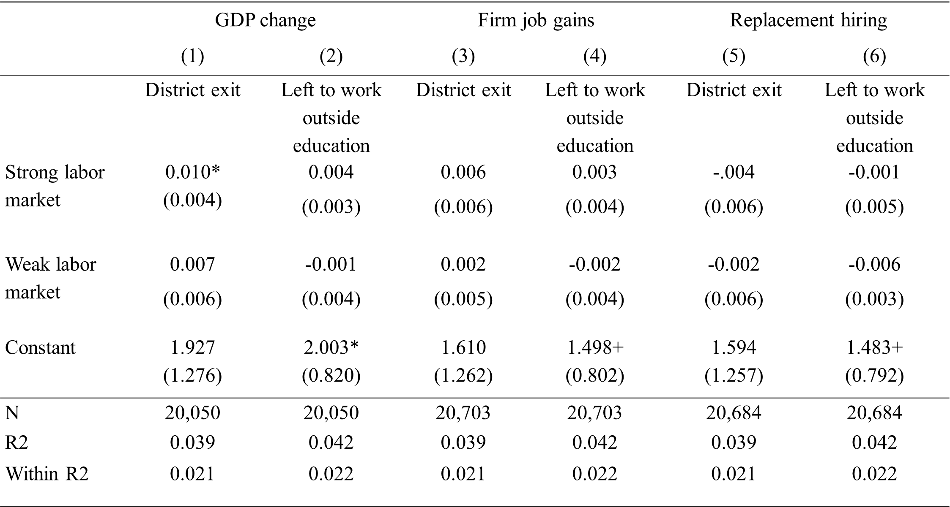
Note. Standard errors in parentheses
+ p<.10, * p<.05, ** p<.01, *** p<.001
All models include district FE, year FE, and cluster FE. “Strong” is defined as values well above the mean for both Firm Job Gains (above 70) and GDP Percent Change (above 15). “Weak” refers to values below 0 for both measures, while the reference category includes values between 0 and 70 for Firm Job Gains and between 0 and 15 for GDP Percent Change. “Strong” for the Hiring and Replacement Rate is defined as values in the highest tercile, representing rates well above the mean. “Weak” refers to values in the lowest tercile, while the reference category includes values in the middle tercile.

Table 5. Interaction Estimates on Unemployment Rate Across Career Clusters
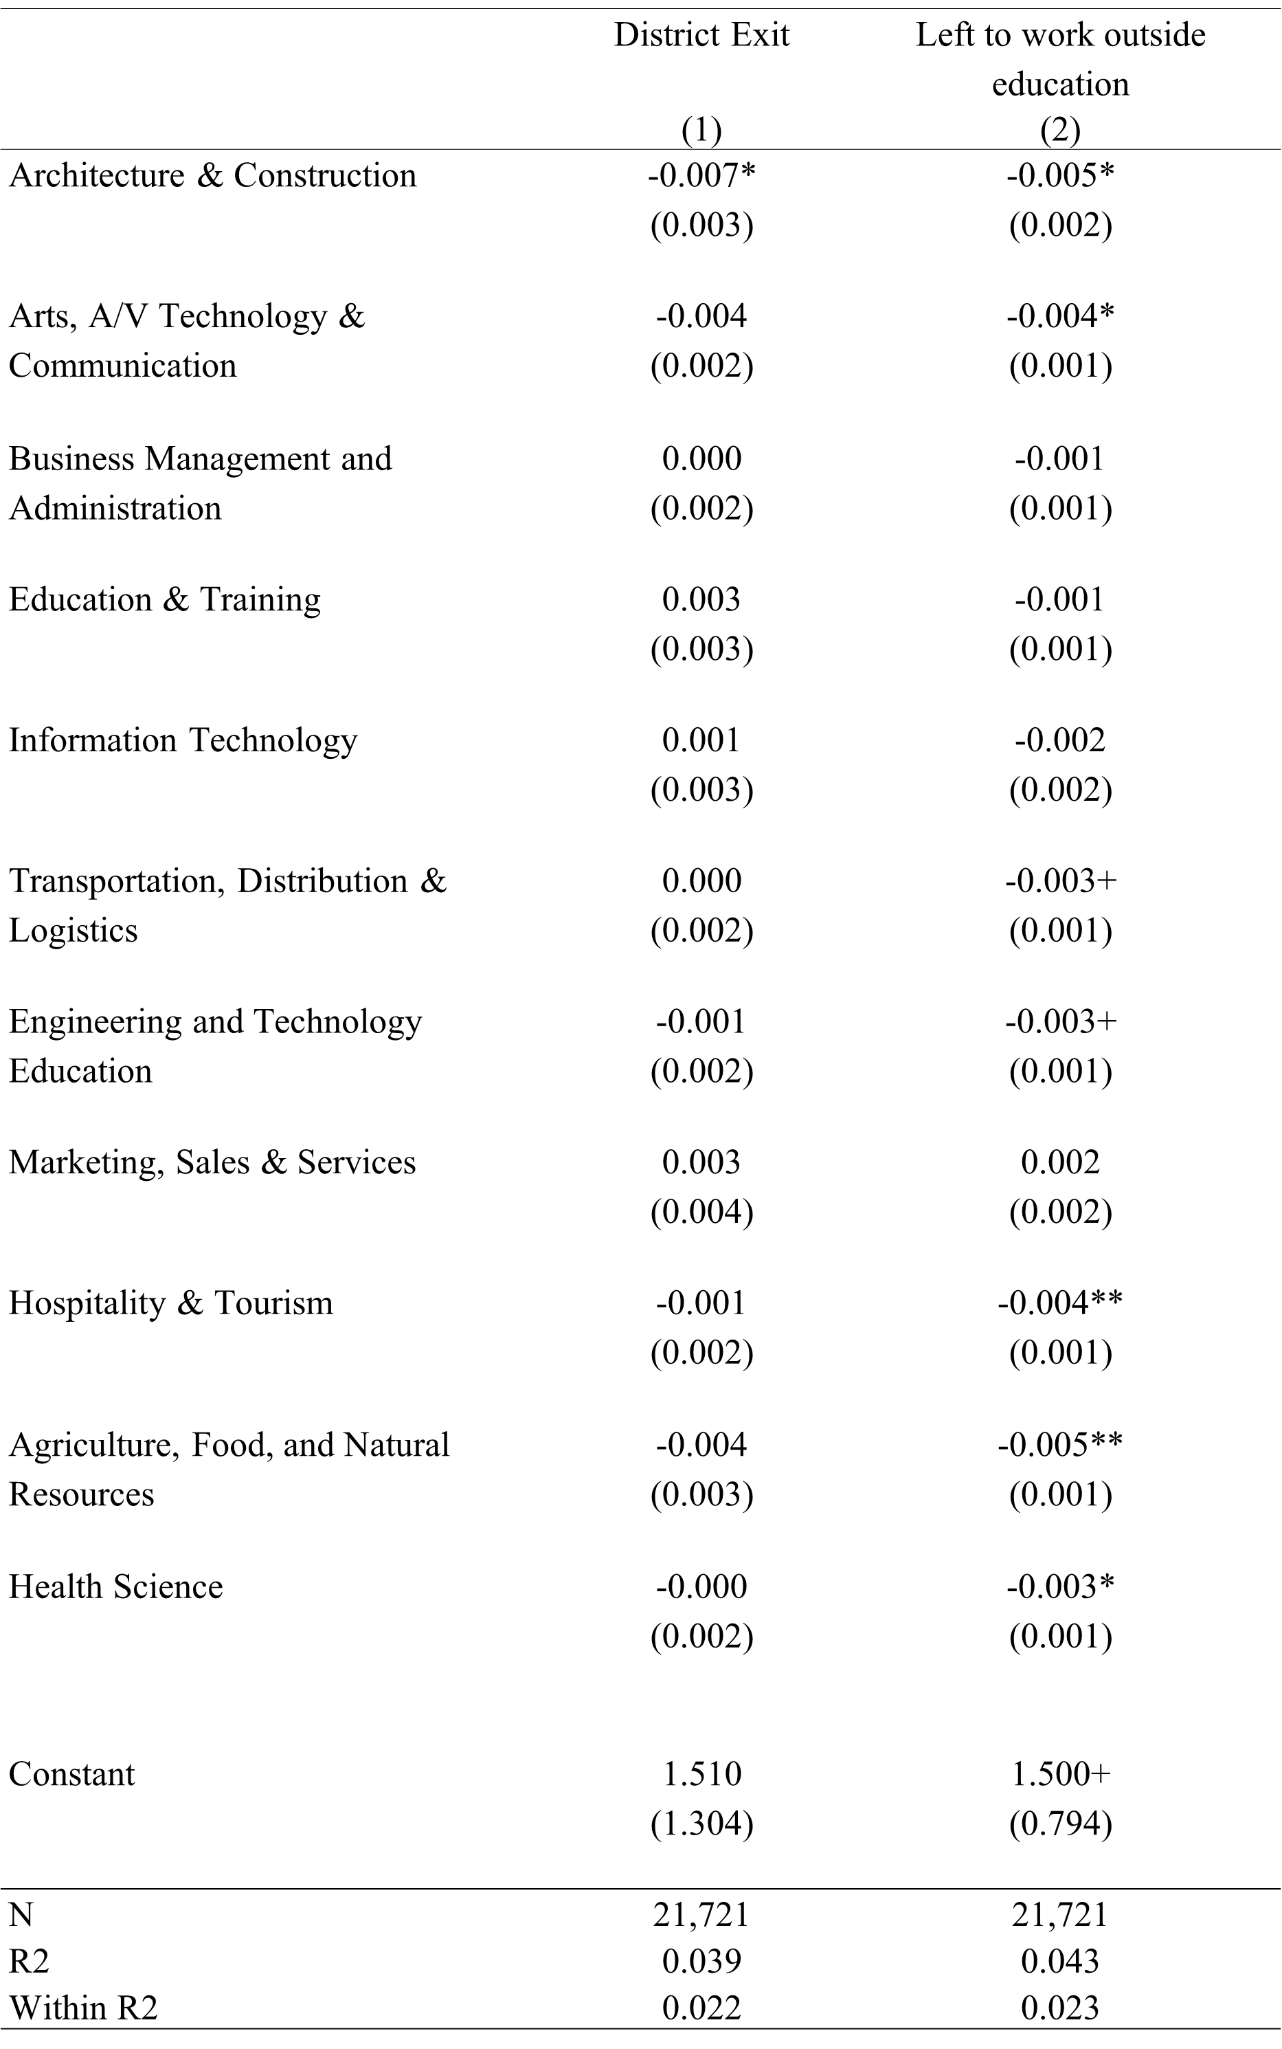
Note. Standard errors in parentheses
+ p<.10, * p<.05, ** p<.01, *** p<.001
All models include year FE, district FE, and cluster FE.
Figure 1. Theoretical Framework

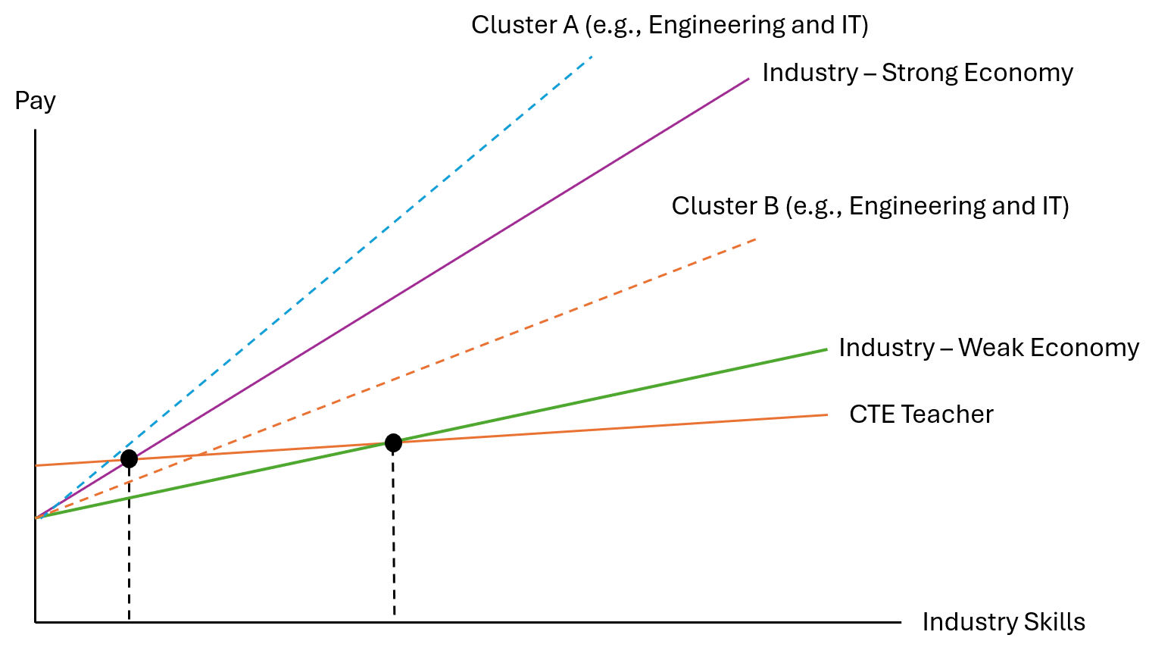
Note. The vertically dashed lines show the decision threshold in a hypothetical strong economy and a weak economy. Under the Roy model (Roy, 1951), a teacher would exit when expected industry earnings exceed expected teaching earnings. In a strong economy, the threshold occurs at lower industry skill, so more teachers will leave teaching for industry. In a weak economy, the threshold occurs at higher industry skill, so only teachers with very high industry skill exit when alternative opportunities are fewer.

Figure 2. District Exit and Teacher Leaving Profession by Year (percent)

